Winter 2024 COMP 3005 Project

Student Names: Jackson Scott

Due: 13/04/12

# Part 1: Conceptual Design

Website only allowed for 60 items per diagram so I had to make multiple, first image show relation between classes, and the next 3 show the attribute for the classes.

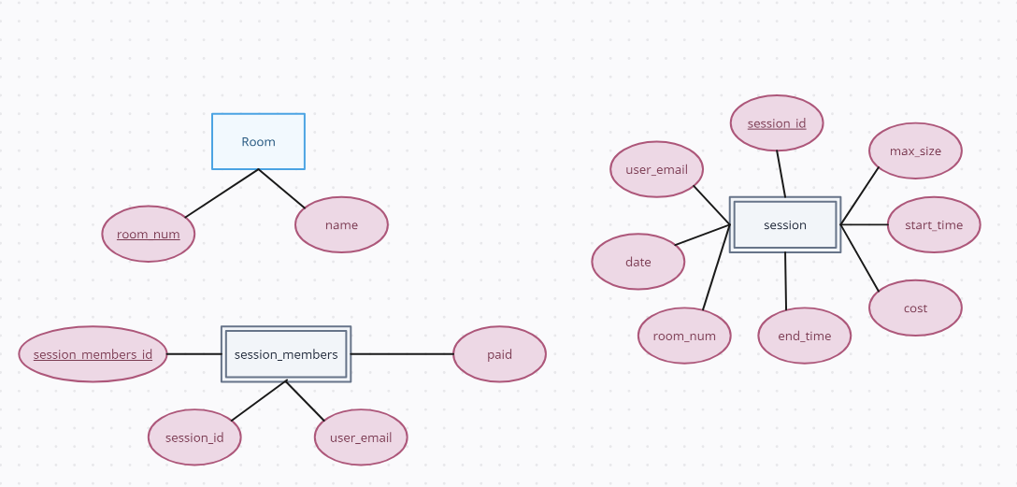

Part 2: Reduction to Relation Schemas

Part 3: DDL File

Included in the file *“CreateTables.sql”*

Part 3: DML File

Included in the file *“LoadTables.sql”*

Dependent on sequence based ID from equipment and session so equipment_maintenace and session members tables aren’t preloaded

# Part 4: Implementation

Broke function up into groups

# Part 5: Bonus Features

Included in the file *“UML_Requirement_Traceability_Matrix___team50.pdf”*